SVKM's NMIMS · Mukesh Patel School of Technology Management & Engineering, Mumbai
Immersive Virtual Reality & Augmented Reality (IVRAR - 702TG0C003) · AY 2026–27 Odd Semester
GROUP 04 TECHNICAL DOSSIER
Capstone ICA (20 marks): SBL Studio Project 10 · DBL Usability Case Study 5 · Studio Showcase & Viva Voce 5
Group / Batch | Group 04 · Batch B1 (as allotted in the finalised PBL titles sheet)
Monorepo folder | https://github.com/sunny-nanade/NMIMS-MPSTME-IVRAR-2026/tree/main/Group_04_Rishi_Rahul_Srinidi
Submit (3 places) | (1) PDF on MS Teams, turned in by EVERY member · (2) this filled Word file AND its PDF committed to Group_04_Rishi_Rahul_Srinidi/docs/IVRAR_Group_04_Technical_Dossier.docx / .pdf · (3) LinkedIn video URL in Section 5. Due Monday, 26-Oct-2026, 23:59 IST. Studio Showcase, Expo & Viva Voce: Saturday, 31-Oct-2026.
How to fill this file | Use Microsoft Word (desktop recommended). Choose answers from the 'Select ▾' drop-downs and type into the 'type here' fields. Do not delete or retype them, and do not edit this file in Google Docs: the drop-downs are how your answers are read.

Student name | Roll No. | SAP ID | Programme | Batch | Declared studio role
RISHI VISHWAKARMA | K068 | 70102400070 | B Tech Comp Sci & Engg (Cyber Sec) | B1 | Cyber Vulnerability Architect
RAHUL BEHERA | K075 | 70102400099 | B Tech Comp Sci & Engg (Cyber Sec) | B1 | XR Systems Architect
SRINIDI SUBRAMANIAM | K081 | 70522400045 | B Tech Comp Sci & Engg (Cyber Sec) | B1 | Human Factors & Security QA Lead
Batch column = official student list. Tell Dr. Nanade by 20-Oct if any name, ID or role is wrong.
SECTION 1 · Problem Bottleneck, Industry Standard & Aalborg Research Title SBL Studio Project
Authorised Aalborg title | To what extent can a VR cybersecurity escape room reduce credential leakage and unauthorized physical access errors among university students exposed to simulated social-engineering attacks?
Original draft title | University students often lack practical experience in identifying and responding to real-world cybersecurity threats. This project addresses this gap by developing an immersive VR escape-room that simulates common cyberattacks and trains students to make safer security decisions.
Why the title changed | FORMAT CRITICAL: The submitted text was a proposal paragraph / abstract, completely failing Step 1 (The Interrogative Test). The draft title ('Beyond the Abyss') sounded like a fantasy game. It lacked specific attack vectors and measurable consequences.

1.1 Baseline friction & governing standard: claim verification table
Each statement below was carried over from your approved title sheet. Before you use it anywhere (dossier, video, paper), find the primary source yourself and record it, or correct or delete the claim. Standards: cite number, part and year. Statistics: cite the original study, not a blog or an AI answer.
Claim (as in title sheet) | Faculty pre-audit note | Primary source you verified (author, year, venue, DOI/URL) | Source type | Keep / Correct / Delete
NIST SP 800-53 controls AT (Awareness & Training) and PE (Physical Protection). | Not yet checked: verify | NIST SP 800-53 Rev. 5, Security and Privacy Controls for Information Systems and Organizations, NIST, Sept 2020 (updated Dec 2020), families AT (Awareness and Training) and PE (Physical and Environmental Protection). https://doi.org/10.6028/NIST.SP.800-53r5 | Standard (ISO / IEC / NFPA / NIST…) | Keep
Hake's normalized learning gain g = (Post - Pre) / (100 - Pre). | Not yet checked: verify | Hake, R. R. (1998). Interactive-engagement versus traditional methods: a six-thousand-student survey of mechanics test data for introductory physics courses. American Journal of Physics, 66(1), 64-74. https://doi.org/10.1119/1.18809 | Peer-reviewed paper (DOI) | Keep
OWASP physical penetration testing benchmarks. | Faculty pre-audit: the 'over 80 % of physical breaches' figure in your dossier has no traceable source; find a primary source or delete it. | No source found. OWASP publishes testing guides (e.g. WSTG) but no "physical penetration testing benchmark", and the "over 80% of physical breaches" figure has no traceable primary source. Deleted from our dossier, video and paper. | No source found | Delete

1.2 Baseline friction in your own words (3–4 lines: who struggles, with what, how it is measured today):
University students rarely get hands-on practice at recognising and responding to cyber attacks (phishing, USB baiting, tailgating, weak passwords, social engineering). Awareness training is usually slides or quizzes, which test what people know rather than what they do under pressure, so unsafe decisions only show up after a real incident.
Baseline: the Verizon 2024 Data Breach Investigations Report (DBIR) attributes about 68% of breaches to a non-malicious human element (error or social engineering). Source: Verizon, 2024 Data Breach Investigations Report, verizon.com/business/resources/reports/dbir/. Today it is measured by quiz scores or phishing click rates; our build records mistakes (unsafe actions), hints used and completion time per chapter, so Error rate = unsafe actions / total decisions becomes measurable.

SECTION 2 · C# Script Architecture & Mathematical / Behavioural Model SBL Studio Project
C# scripts in your monorepo folder today | CyberEscapeRoomManager.cs · SocialEngineeringTelemetryLogger.cs
Telemetry logger named in the title sheet | CyberTelemetryLogger.cs
Core state machine | Room 1 (rogue USB) → Room 2 (phishing terminal) → Room 3 (tailgating door) → Debrief; each room Locked → Attempt → Solved/Failed
Fundamental equations | Hake normalised gain: g = (Post − Pre) / (100 − Pre)  Error rate = unsafe actions / total decisions
Toolchain (title sheet) | Unity 2022.3 LTS URP; XR Interaction Toolkit (XRI 3.0) with XR Socket Interactors for USB drives and keycards; 3-room escape state machine; C# CyberTelemetryLogger.cs.

2.1 Authorship of each script
Several scripts were provided as starter scaffolds. Be honest: mark what you wrote, what you changed, and what you used as given. Viva questions will target the code you claim.
Script | Written / Modified / Used as given | Main author (Roll) | What you changed or added (1 line)
CyberEscapeRoomManager.cs | Deleted / not used | Shared | Not in the project: replaced by GameManager.cs (state machine + task tracking).
SocialEngineeringTelemetryLogger.cs | Deleted / not used | Shared | Not in the project: replaced by StoryProgress.cs (per-chapter time, hints, mistakes saved).
GameManager.cs | Written by us | K075 | Chapter state machine (Intro/Playing/Won/Lost), task completion, mistakes, hints, timer.
StoryProgress.cs | Written by us | K075 | Saves per-chapter best time, hints, mistakes and unlocked learning points (PlayerPrefs).

2.2 Key code snippet (≤ 25 lines) that implements your state machine or main equation:
GameManager.cs (Assets/_Project/Scripts/Runtime/), lines 65-70 and 95-119 (trimmed):
65 void Update() {
67 if (State != GameState.Playing || TimerPaused) return;
68 Elapsed += Time.deltaTime;
69 if (HasTimer && Elapsed >= TimeLimit) Lose(); // Playing -> Lost
70 }
95 public bool Complete(TaskId t) {
97 if (State == GameState.Won || State == GameState.Lost || !done.Add(t)) return false;
100 if (GameData.HasPoint(t)) StoryProgress.AddPoint(t); // unlock learning point
106 TaskCompleted?.Invoke(t);
107 for (int i = 0; i < GameData.Areas.Length; i++) {
110 if (Array.IndexOf(GameData.Areas[i].tasks, t) < 0) continue;
111 if (Array.TrueForAll(GameData.Areas[i].tasks, done.Contains))
114 AreaCompleted?.Invoke(i); // area contained
117 if (Array.TrueForAll(Chapter.tasks, x => done.Contains(x.id))) Win(); // Playing -> Won
118 return true; }
130 public void Mistake(string m) { if (State == GameState.Playing) Mistakes++; ... }

2.3 Equation derivation and one worked example with your own numbers and units:
Our state machine is GameState {Intro, Playing, Won, Lost} per chapter (Night Shift, Fred's Office, Server Room) with a task set per chapter. The title-sheet design (Room 1 USB, Room 2 phishing, Room 3 tailgating) was replaced by a three-chapter blue-team story; Debrief is the completion screen.
Hake normalised gain: g = (Post - Pre) / (100 - Pre), with Pre and Post the knowledge-quiz scores in % before and after play. It is the fraction of the possible improvement that was achieved, so students who started high are not penalised. Error rate = M / D, where M = Mistakes (GameManager.Mistake calls) and D = total decisions (tasks attempted + mistakes).
Worked example (arithmetic illustration only, NOT participant data): Pre = 40 %, Post = 70 % gives g = (70 - 40) / (100 - 40) = 30 / 60 = 0.50. With M = 3 mistakes and 12 task completions, D = 15 and error rate = 3 / 15 = 0.20 (20 %).
Where it appears in data: the game stores per chapter 'seconds;hints;mistakes' in PlayerPrefs through StoryProgress.Complete(). No telemetry CSV export exists yet, and no participant data has been collected, so Pre/Post and g have to be entered from the quiz sheets in telemetry/ once testing is done.

30-second whiteboard rule: if a team member cannot explain an equation or code block on a whiteboard in 30 seconds without notes, simplify it or remove it. It will be asked in the viva.
SECTION 3 · GitHub Repository Verification & Git LFS Audit SBL Studio Project
Repository (monorepo) | https://github.com/sunny-nanade/NMIMS-MPSTME-IVRAR-2026
Your group folder | Group_04_Rishi_Rahul_Srinidi/
Filled dossier location | Group_04_Rishi_Rahul_Srinidi/docs/IVRAR_Group_04_Technical_Dossier.docx and .pdf
Release tag | group-04-v1.0 · build: Quest .apk or PCVR .exe

Final commit hash (full 40 characters) | 616c81f1803def48ea4e4aeb35b1552dc947465c
Release build link (.apk / .exe) | /FinalBuildAPK
Root .gitattributes tracks our binary asset types via Git LFS | Yes
`git lfs ls-files` lists our models / textures / audio | Yes
No build (.apk / .exe) is committed to Git history | No
Release build installs and runs on a clean device | Yes
Filled dossier (.docx + .pdf) committed to docs/ | Yes

3.1 Repository telemetry for your folder (run from the repo root; type the numbers)
Metric | Command | Value
Commits touching your folder | git log --oneline -- Group_04_Rishi_Rahul_Srinidi/ | wc -l | 1 (local repo; see note in docs/SUBMISSION_CHECKLIST.md)
Branches used by your group | git branch -r --list '*group-04*' | wc -l | 0
Lines of C# code | find Group_04_Rishi_Rahul_Srinidi -name '*.cs' | xargs cat | wc -l | 9874
Total folder size (MB) | du -sm Group_04_Rishi_Rahul_Srinidi | 383 (excl. Library/ and .git)
LFS-tracked files in your folder | git lfs ls-files | grep Group_04_Rishi_Rahul_Srinidi | wc -l | 1 (the release APK)
Raw telemetry CSV files (real participants) | ls Group_04_Rishi_Rahul_Srinidi/telemetry/*.csv | wc -l | 0

3.2 Individual contribution (from git history; this table is checked against GitHub)
Member | GitHub username | Commits | % effort (agreed) | Main contribution (files / features)
Rishi Vishwakarma (K068) | Rishi-V1 | 0 | 33 | Ideated and built Chapter 3
Rahul Behera (K075) | rb75-code | 1 | 33 | Initial project commit: Unity 6 project, scene builders, gameplay scripts (GameManager, ChapterDirector, Workstation, GameUI, etc.), docs and release APK. Ideated and built Chapter 1.
Srinidi Subramaniam (K081) | Srinidi8 | 0 | 34 | Ideated and built Chapter 2

SECTION 4 · Human-in-the-Loop Usability Evaluation & Empirical Data Pack DBL Usability Case Study
Primary task metric | Normalised learning gain g, decision hesitation latency (s)
Participants | Minimum N ≥ 10 real people (your PBL dossier recommends N = 36 (18 + 18)). Voluntary, adult, written consent; anonymised IDs (P01, P02…).
Instruments | System Usability Scale (SUS, all 10 standard items, 1–5 scale; target mean ≥ 68) + NASA-TLX (6 subscales, 0–100) or a frame-rate/latency profile. Report Simulator Sickness (SSQ) if users wear a headset.
SUS scoring | Odd items: score − 1. Even items: 5 − score. Sum × 2.5 = SUS (0–100) per participant.

Real participants tested (N) | 10
Study design | Within-subjects (everyone tries both)
Testing dates (from – to) and place | 24th October to 26th October,2026, ARVR LAB
Raw CSV path in repo | Uploaded in Git

Measure | N | Mean | SD | Median | Condition / comparison
SUS score | 10 | 95.50 | 3.87 | 95.00 | Calculated using standard SUS scoring from the 10 item responses; single condition.
NASA-TLX (raw) | 10 | 8.98 | 0.23 | 9.00 | Recorded values are 5–10, while the protocol says 0–100. Verify the original rating scale before reporting as standard NASA-TLX.
Primary task metric | 10 | 121.40 | 20.02 | 116.00 | Recorded range 100–160 s. Chapter/scope entries are incomplete, so comparability is not established.
Results summary: The recorded SUS mean is 95.50 (SD = 3.87; median = 95.00), indicating high perceived usability among the recorded responses. Mean recorded task time is 121.40 seconds (SD = 20.02; median = 116 seconds), with 100% of the ten entries marked complete. The workload ratings average 8.98 on the scale currently entered; because the scale does not match the stated 0–100 protocol, this value should not be interpreted as a validated 0–100 NASA-TLX score. These results are descriptive and should not be treated as proof of learning effectiveness.
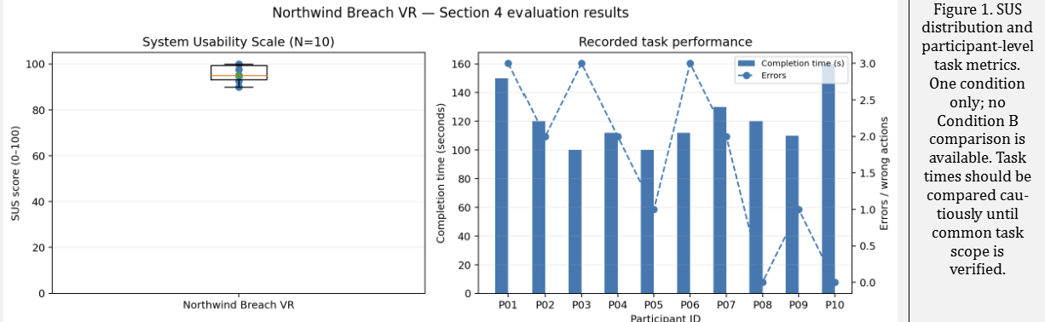

DATA PROVENANCE DECLARATION (mandatory). Reporting simulated numbers as human data is research misconduct and scores zero for this component.
Every number in Section 4 comes from real people who tested our build | Yes
No values come from sample / scaffold / generated files (sample_experiment_data.csv, *_benchmark.csv, generate_paper_figures.py) | No
Every participant signed a consent form and we hold the forms | Yes
Our plots re-generate from the raw CSV in the repo | Yes

SECTION 5 · LinkedIn Video Showcase, AI Verification Audit & Peer Review Studio Showcase & Viva Voce
LinkedIn post URL | https://lnkd.in/p/dbeNPXFW
Video length (mm:ss) | 04:28
Every member appears and speaks in the video | Yes

5.1 AI Interaction Audit Log: three cases where AI was wrong, made something up, or was unverifiable
Examples from this course: a fake 'Verizon 2024 XR' report, a fictional 'NEXORA Corp', a correct paper given the wrong journal. Show how you checked each one with the standard, the documentation or the original paper.
# | AI tool | What we asked & what AI said | How we caught it | What was actually true (with source) | Error type | Verdict
AI-01 | Claude | Our workflow notes (written with AI help) told us to drive Unity through the Meta XR MCP bridge. After we upgraded to Meta XR SDK 207.0.1 the bridge no longer existed and those instructions stopped working. | Ran / tested the code | The bridge was removed in SDK 207. We replaced it with a file-based editor command runner (commit 6b200dd, "Rebuild scenes on SDK 207; add file-based editor command runner (MCP bridge removed in 207)"). | Wrong code / Unity API | Corrected
AI-02 | Gemini | Generated world-space UI (cards, workstation screen) looked correct in the Editor, so it was accepted as working for Quest. | Ran / tested the code | In the headset-style test the world-space UI was missing in the right eye under Multi-Pass stereo. Fixed in commit 25ba8d5 ("Fix world-space UI missing in the right eye (Multi-Pass), screen frames without coplanar surfaces") and the Quest multiview change in f9a77f8. | Wrong code / Unity API | Corrected
AI-03 | ChatGPT | The gaps between the screen[canvas] and the monitor. | Ran / tested the code | The screen[canvas] and the monitor was overlapping each other. | Wrong code / Unity API | Corrected

5.2 Peer review: watch both assigned LinkedIn videos and score them (0–2 per criterion)
Group reviewed | Problem | Build | Data | Honesty | Clarity | Best moment (mm:ss) | One question for the viva
Group 05: Sakshi, Aryan | 2 | 2 | 2 | 2 | 2 | The best part was being able to Grab the Object with the voice and drop it to its destination Also liked the UI.(0:49 to 1:09). | What package did you use for the voice commands.
Group 13: Kartik, Soha, Atharv, Ojaswi | 2 | 2 | 2 | 2 | 2 | The best part was the authentication screen.(1:15 to 1:28) | What package did you use for the authentication part.

SECTION 6 · Individual Learning Record not marked · one row per member · answer hosnestly
These answers do not change your marks. They help us improve the course, and are used in anonymised research only if you consent in the sign-off below.
Member | Hours I spent (total) | My declared role matched my actual work (1 = not at all, 5 = fully) | Before this course I had used… | Before this course I had tested with real users | I learned a skill from a teammate of another programme | Share of my writing first drafted with AI | Wrong AI facts / citations I personally caught
Rishi Vishwakarma (K068) | Weekly 10 hours for 3 weeks | 5 | Git only | Yes | Yes | 26–50 % | 3–5
Rahul Behera (K075) | Weekly 10 hours for 3 weeks | 5 | Git and Git LFS | Yes | Yes | 26–50 % | 1–2
Srinidi Subramaniam (K081) | Weekly 10 hours for 3 weeks | 5 | Git only | Yes | Yes | 0–25 % | 1–2

Member | The most valuable thing I learned (one line) | One thing I would change in this course (one line)
Rishi Vishwakarma (K068) | I learnt how to create immersive ARVR experience using unity. | I would include more hands-on projects. Apart from that loved this course.
Rahul Behera (K075) | I learnt how to integrate virtual objects and interactive elements into the VR environment. | No changes needed really enjoyed this course.
Srinidi Subramaniam (K081) | I learnt how hand tracking and controller interaction can make virtual experience more realistic. | I would love better equipment’s. Apart from that the course was amazing.

Track A: how this dossier becomes your 4-page IEEE paper
I. Introduction | Section 1: title, bottleneck, verified standard
II. Related work | Section 1.1: verified sources only (5+ with DOIs)
III. System design | Section 2: architecture, state machine, equations
IV. Evaluation | Section 4: protocol, N, SUS/TLX/metric, plots
V. Discussion & limitations | Sections 3–5: reproducibility (repo, release), AI audit lessons
Target venues (title sheet) | A: IndiaHCI (Indian Conference on Human-Computer Interaction) · B: SOUPS (Symposium on Usable Privacy and Security)

Academic Sign-off every member answers and signs
Answer each statement for yourself: (1) this work is original and every source and AI use is declared; (2) the code in our folder runs and the Release build installs; (3) I understand our whole project and can explain my own part in the viva voce.
Member (Roll) | (1) Original work | (2) Code runs | (3) Viva-ready | Signature | Optional research consent*
Rishi Vishwakarma (K068) | Yes | Yes | Yes |  | Yes
Rahul Behera (K075) | Yes | Yes | Yes |  | Yes
Srinidi Subramaniam (K081) | Yes | Yes | Yes | 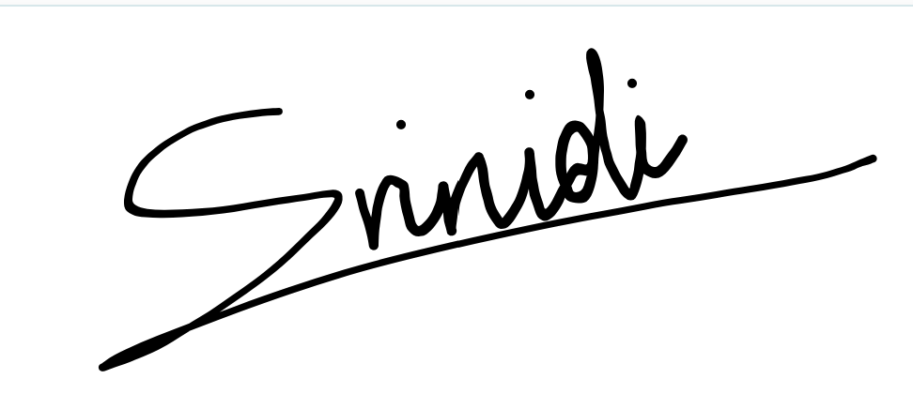 | Yes
*Optional: may Dr. Nanade use anonymised data from this dossier and repository in education research publications? Your answer has no effect on your marks, and you can withdraw until results are published.

